Manufacturing Tool V2 (MFGTool2) Quick Start Guide

Contents
Overview 2
For MFGTool V1.x User 6
How to Burn Your Own Image with Manufacturing Tool 8
Command line feature 8

Overview(概述)
This document describes a simple step-by-step guide on how to use Manufacturing (MFG) tool V2 and some Q/A which may be referred to frequently.
本文档将通过简单的一步一步指引你如何使用MFG工具V2版本，并且文档中包含一些Q/A有可能你会需要经常的参考。

OK, let’s begin.
好的，让我们现在开始
- Step 1（步骤1）
Before running the application, there are two files which must exist in the same folder with the application: cfg.ini and UICfg.ini. Additionally, the corresponding configuration must be set correctly. An incorrect configuration will cause the application to work abnormally.
在开始运行这个应用程序之前，在该应用程序文件夹目录下cfg.ini和UICfg.ini这两个文件必须存在，另外相应的配置信息也必须设置正确。如果配置错误将造成应用程序工作异常。
- The UICfg.ini file is used to configure the number of ports which indicates how many boards can be supported simultaneously.
UICfg.ini文件用来配置同时可以支持多少块板子一起烧录。
The format of the UICfg.ini file is as indicated below:
UICfg.ini文件的格式如下所示：
[UICfg]
PortMgrDlg=1
For example, if only one board at a time will be supported, "PortMgrDlg=1" should be set. Currently, Up to four boards can be supported, so PortMgrDlg can be set to 1-4.
例如，如果只有仅支持一块板子烧录，PortMgrDlg必须设置为1。当前软件最大支持4块板子同时烧录，所以PortMgrDlg的值只能设置为1-4范围内。
- The cfg.ini file is used to configure the target chip profile and target operation list.
cfg.ini文件用来配置目标芯片的轮廓和目标操作列表。该文件的格式如下所示：
The format of this file looks like like the following:
[profiles]
chip = MX6DL Linux Update

[platform]
board = ARM2

[LIST]
name = Android-SD
“profiles/chip” indicates the target profile name, and “list/name” indicates the target operation list name which can be found in the file located at "profiles/CHIP_PROFILE/OS Firmware/ucl2.xml". Currently, the “platform/board” is reserved and not used, please ignore it.
“profiles/chip”用来描述目标文件名称，”list/name”用来表示对目标的操作列表名称。对于这些操作列表可以在profiles/CHIP_PROFILE/OS Firmware/ucl2.xml文件中找到。对于目前版本”platform/board”暂时没使用作为保留，可以忽略它。
- Step 2（步骤2）
Set the correct boot mode and connect the OTG port to the PC on which the MFG Tool application will be run.
在开始运行MFG工具前，板子需要设定好正确的启动模式并且板子的OTG端口连接到电脑PC端的USB口。
To set the correct boot mode, refer to the Linux BSP User Guide document.
可以参考LinuxBSP用户指南文档来设定正确的启动模式。
After connecting to PC with the correct boot mode setting, a HID-compliant device will be shown in the Device Manager as shown below:
在设定正确的启动模式后连接到电脑PC，在设备管理器下可以看到HID-compliant被识别到。如下图所示：
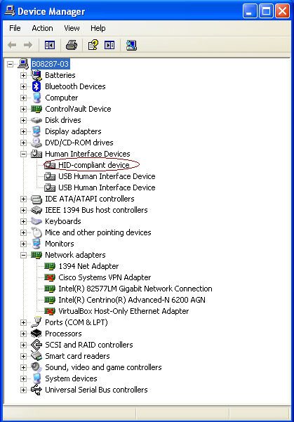
- Step 3（步骤3）
Double click the application to run.
双击并运行该应用程序。
There is a limitation that, when using the MFGTool V2 for the first time to burn an image to a device (such as: i.MX 6Quad ARM2, i.MX 6DualLite Sabre-SD, and so on), the device must be connected to PC before MFGTool V2 starts running.
在运行MFG V2工具时有一个限制就是当第一次烧录一个镜像到设备上时，设备必须连接到PC。
Only two buttons can be clicked, Start/Stop, and Exit.
应用程序只有两个按钮可以点击，一个是Start/Stop和Exit。
Start/Stop is used to start/stop the burning process. If you re-start the burning process after you stop it, the process will try to continue from the point where you stopped before, but it is not guaranteed that it can continue successfully. It is NOT recommended to do this.
Start/Stop按钮是用来启动或停止烧录过程。如果在你停止烧录后再次重新启动烧录，程序将从你之前停止烧录的那个位置处继续往下烧录，之后可以继续烧录直到成功，但是否烧录正确是无法保证的。建议最好不要这么操作。
Exit is used to exit this application. Please note that you can exit the application only after you stop the burning process.
Exit按钮是用来退出该应用程序的。注意只有停止烧录过程时才可以退出该应用程序。
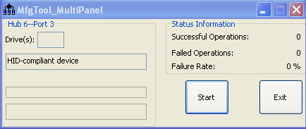
- Step 4（步骤4）
Click “Start” button. If you have a terminal tool to monitor the debug serial port of your board, it is suggested to open it. You can get more information from it.
点击“start”按钮。如果你有终端调试工具来查看你的板子的调试信息，建议打开它。你可以从终端中获取更多的信息。
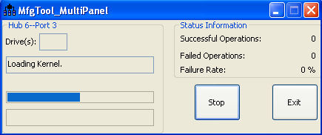

Process continuing:（烧录过程）
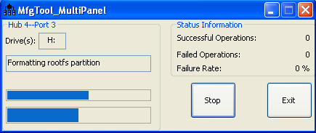
You can find information from the terminal.你可以在终端中查看到这些信息
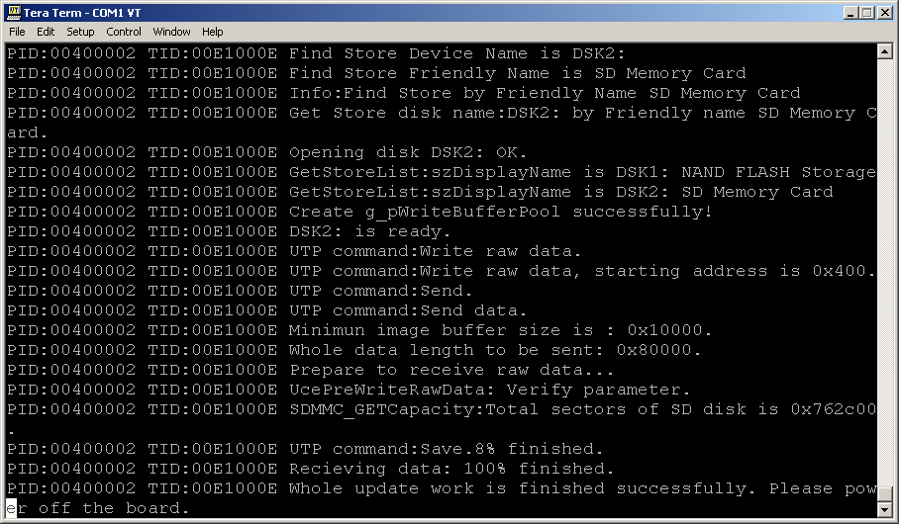

It is done. Click “Stop” to finish, and Click “Exit” to terminate the application.
烧录完成。单击“Stop”按钮并且点击“Exit”来退出应用程序。
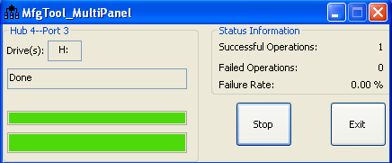

- Note: The manufacturing tool may sometimes report an error message when it is downloading the file system to the SD card. This can be caused by insufficient space in the SD card due to a small partition size. To fix this, unzip the file "Profiles\ CHIP_PROFILE \OS Firmware\mksdcard.sh.tar" and then modify the script to increase the size of the partition and create more partitions according to your file system requirements. After the modification is done, tar the script again.
- 注意：当下载文件系统到SD卡上时,MFG工具有可能有时会报告一个错误消息。造成该错误的原因是由于SD卡分区太小造成SD卡磁盘空间不足。对于该问题可以通过解压Profiles\CHIP_PROFILE\OS Firmware\mksdcard.sh.tar文件并根据你的文件系统要求修改增加分区大小或是创建多个分区脚本，修改完后再重新打包这个脚本。

For MFGTool V1.x User
MFG tool V2.0 uses ucl2.xml which is different than V1 in which ucl.xml is used.
All description about ucl.xml in V1 documents can be applied to ucl2.xml, with small changes as shown below:
MFG工具V2.0版本使用的ucl2.xml与V1.0版本使用的ucl.xml文件有一定的区别。在V1.0版本中所有关于ucl.xml文件的描述都可以应用于ucl2.xml文件，仅有一小部分的改变，如下所示：
- The <STATE>...</STATE> item is simplified, <state>…</state>标签更简单
Old format in ucl.xml 在ucl.xm旧格式中
<STATE name="Recovery" dev="MX6Q"/>
<DEV name="MX6DL/Solo" vid="15A2" pid="0054"/>

New format in ucl2.xml 在ucl2.xml新格式中如下：
<STATE name="BootStrap" dev="MX6Q" vid="15A2" pid="0054"/>

For state “BootStrap”, the valid strings for dev are: "MX6Q", "MX6D", "MX6SL". Others are invalid.
对于“BootStrap”状态，设备的有效字符串为“MX6Q”,”MX6D”,”MX6SL”,其它字符串均无效。
For state “Updater”, the valid string for dev is: “MSC”. This name is constant for all the SoC.
对于“Updater”状态，设备有效的字符串为”MSC”.这个名字对于所有的SOC都是不变的。
The valid strings for state name are: "BootStrap", "Updater". Others are invalid.
对于状态名称有效的字符串为”BootStrap”，”Updater”.其它均为无效。

- Add a “state” attribute into each <CMD.../>. This attribute specifies the state that this command will run in, for example:
Old format in ucl.xml:
添加状态属性到每个<CMD…/>。这个属性指定了这个命令将要运行的状态。例如：

<CMD type="boot" body="Recovery" file ="u-boot-mx6sl.bin" >Loading U-boot</CMD>

New format in ucl2.xml:（在ucl2.xml文件中的新格式）

<CMD state="BootStrap" type="boot" body="Recovery" file ="u-boot-mx6sl.bin" >Loading U-boot</CMD>

It indicates that this command will be running at BootStrap state.
它指示了该命令将运行在BootStarap状态下。

- “state” concept“state”概念
In general, the whole burning process includes two phases:
在通常情况下，整个烧录过程分为两个阶段。
- BootStrap—启动引导。
In this phase, the MFG tool will burn the specific U-Boot image and kernel image to the target board, so that MFG tool firmware can run successfully on the target board.
在这个阶段中，MFG工具会烧录特定的U-Boot镜像和内核镜像到目标板子上。以便MFG工具固件可以成功在目标板子上运行。
- Updater—更新
Host side application builds connection with firmware and transfers the U-Boot image and kernel image which will be used normally with the firmware. Eventually, firmware burns these images or roofs to the storage to finish the whole process.
主机端的应用程序与固件建立连接并且可以正常使用固件来传输U-Boot镜像和内核镜像到目标板子上。最终，固件烧录这些镜像或文件系统roofs到存储器上完成整个烧录过程。

- The “find” command is not used anymore. It needs to be removed from the ucl script. Find命令将不再使用，它必须从ucl脚本中移除。

- The last command, the command text must be "Done" (case-insensitive)
最后一个命令，命令的文本内容必须为“Done”（不区分大小写）
For example:
<CMD state="Updater" type="push" body="$ echo Update Complete!">Done</CMD>

How to Choose the Dedicated Storage Device on the Dedicated Board
如何在特定的板子上选择特定的存储器。
One operation list is dedicated for one kind of storage on the dedicated board.
在特定的板子上的一种存储器只有一个特定的操作列表。
You can get this information from the operation list name in ucl2.xml.
你可以在ucl2.xml文件中的操作列表名字中获取到这个信息。
For example, “<LIST name="Sabre-SD" desc="Choose SD as media">” indicates this operation will burn image to SD on Freescale Sabre-SD reference board.
例如：”<LIST name=”Sabre-SD” desc=”Choose SD as media”>表示该操作将烧录镜像到飞思卡尔Sabre-SD参考板子上的SD卡里。
“<LIST name="ubuntu-SabreSD-eMMC" desc="Choose eMMC as media">” indicates this operation will burn image to eMMC on Freescale Sabre-SD reference board.
“<LIST name=”ubuntu-SabreSD-eMMC” desc=”Choose eMMC as media”>”表示该操作将烧录镜像到飞思卡尔Sabre-SD参考板子上的eMMC里。
“<LIST name="ARM2-SD" desc="Choose SD as media">” indicates this operation will burn image to SD on Freescale ARM2 reference board.
“<LIST name=”ARM2-SD” desc=”Choose SD as media”>”表示该操作将烧录镜像到飞思卡尔ARM2参考板子上的SD卡里。

How to Program a Fuse 如何编程熔丝位。
MfgTool V2 supports writing the specified value into the fuse.
The OTP fuse can be written through the following commands:
MFG V2工具支持可以向熔丝位中写入特定值。OTP熔丝位值可以通过下列命令来进行写入。
<CMD state="Updater" type="push" body="$ ls /sys/fsl_otp ">Showing HW_OCOTP fuse bank</CMD>

<CMD state="Updater" type="push" body="$ echo 0x11223344 > /sys/fsl_otp/HW_OCOTP_MAC0">write 0x11223344 to HW_OCOTP_MAC0 fuse bank</CMD>

<CMD state="Updater" type="push" body="$ cat /sys/fsl_otp/HW_OCOTP_MAC0">Read value from HW_OCOTP_MAC0 fuse bank</CMD>
The fuse bank name (ex: HW_OCOTP_MAC0) should be changed according as needed.
熔丝位的名称(ex:HW_OCOTP_MAC0)需要根据所需要的来选择。

How to Burn an Image如何烧录一个镜像。
In the file ucl2.xml located at Profiles\ CHIP_PROFILE\OS Firmware, you can find instructions like this:
在Profiles\CHIP_PROFILE\OS Firmware目录下的ucl2.xml文件中可以找到如下指令：
<CMD state="Updater" type="push" body="send" file="files/u-boot-mx6q-arm2.bin">Sending u-boot.bin</CMD>
<CMD state="Updater" type="push" body="$ dd if=$FILE of=/dev/mmcblk0 bs=1k seek=1 skip=1 conv=fsync">write u-boot.bin to sd card</CMD>
<CMD state="Updater" type="push" body="send" file="files/uImage">Sending kernel uImage</CMD>
<CMD state="Updater" type="push" body="$ dd if=$FILE of=/dev/mmcblk0 bs=1M seek=1 conv=fsync">write kernel image to sd card</CMD>
The value of key word “file” here means the relative path (based on ucl2.xml path) of the image to be burned.
在这里的关键字”file”的值表示要烧录的镜像的相对路径（基于ucl2.xml的路径）。
Key word “send” indicates this file will be sent to target.
关键字”send”表示这个文件将被发送到目标板子上。
After file is received by target device, we can use “dd” command to burn the file to the related storage. “dd” is a standard Linux command. For detailed information refer to the i.MX 6Dual/6Quad Linux Reference Manual.
当目标设备接收完该文件后，我们可以使用dd命令来烧录文件到相关的存储器中。”dd”是Linux中的标准命令。更多关于dd的详细命令可以参考i.MX6Dual/6Quad Linux参考手册。

How to Burn Your Own Image with Manufacturing Tool
如何通过MFG工具来烧录你自己的镜像。
The processes above are limited to the reference design boards provided by Freescale. All the U-Boot images and kernel images are used to support Freescale reference design boards. If you want to utilize the tool to burn your own image on your own board, all you need to do is the following:
上述过程仅限于在由飞思卡尔提供的参考设计板子上进行。所有的U-Boot镜像和kernel镜像仅用来支持飞思卡尔参考设计板子。如果你想使用这个工具在你自己的板子上烧录你自己的镜像，你所需要的操作如下：
- Generate a special U-Boot image and kernel image for MFG tool
为MFG工具生成一个特定的U-Boot镜像和内核镜像。
- Generate a normal U-Boot image and kernel image, maybe customizing rootfs which can be used by the end user.
生成一个通用的U-Boot镜像和内核镜像，有可能定制对终端用户可以使用的rootfs文件系统。
- Refer to the ucl2.xml to create your own operation list. Usually, only changing the original image (U-Boot and kernel) is enough.
参考ucl2.xml文件创建你自己的操作列表。通常仅修改U-Boot和kernel源镜像文件就足够了。
The detailed information about how to generate Manufacturing firmware, refer to the Document “Manufacturing Tool v2 Linux or Android Firmware Development Guide.”
更多详细的关于如何生成MFG工具固件的信息可以参考Document文件下的“MFG工具V2版本Linux或Android固件开发指南”。

Command line feature命令行功能。
MfgTool2 can support command line feature, the commands that can be accepted are “-c, -l, -p and -noui”.
MFG工具支持命令功能，这些可以被接受的命令为：”-c,-l,-p和-noui”.
The format of command line looks like:
命令行格式如下：
MfgTool2.exe [-noui] [-c] [“chip profile folder name”] [-l] [“list name”] [-p] [number] [-s] [“variable=value” ]
Parameters description:
参数描述：
- -noui: this command has no any parameter, if this command is used, the application will use the console interface, otherwise, the GUI interface will be used.
- -noui:这个命令没有任何参数，如果使用这个命令，程序将使用控制台接口，否则就使用GUI接口。
Note: this command must be the second parameter (the first parameter is application name), if it is used.
注意：如果使用这个参数，命令必须作为第二个参数(第一个参数为应用程序名)
- -c: indicate the target profile name. The parameter of this command is a string with a pair of double quotes.
- -c：表示目标文件名字。这个命令的参数是包含双引号的字符串。
- -l: indicate the target operation list name which can be found in the file located at "profiles/CHIP_PROFILE/OS Firmware/ucl2.xml". The parameter of this command is a string with a pair of double quotes.
- -l：指示目标文件的操作列表名称，可以在profiles/CHIP_PROFILE/OS Firmware/ucl2.xml文件里找到这个操作列表名称。这个命令的参数是一个包含双引号的字符串。
- -p: indicate the number of ports which indicates how many boards can be supported simultaneously. The parameter of this command must be a number between 1 and 4.
- -p：表示端口的数量，支持有多少块板子可以同时烧录。这个命令的参数必须设定为1到4之间。
- -s: Set ucl variable value. Support multiply if you need set more one variable.
-s：设定ucl变量值。如果你需要设定多个变量可支持多个变量。

- All above parameters are not mandatory, if no parameter in the command line, the application will try to find the parameter from the corresponding file, e.g. if ‘-c’ parameter is not provided in the command line, the application will try to get it from ‘cfg.ini’ file just like 65+the v2.0.x, if the application can't get the parameter from both the command line and cfg.ini file, the application will fail to run.
- 以上的所有参数不是强制需要的。如果命令行里没有参数，应用程序将尝试从相应的文件里查找，例如，如果-c参数在命令行里没有提供参数，应用程序将尝试从cfg.ini文件里获取。如果应用程序不能在命令行和cfg.ini文件里获取到参数，应用程序将运行失败。
- If both command line and cfg.ini/UIcfg.ini assign the same parameter, the application will take the command line parameter with priority.
如果在命令行和cfg.ini/Uicfg.ini文件里指定相同的参数，程序将有优先采用命令行里的参数。
- Press CTRL+C or the Close button to close the APP.
- 按下CTRL+C或关闭按钮来关闭应用程序。

Some examples on how to use command line feature:
以下示例展示如何使用命令行功能：

- MfgTool2.exe –noui –c “MX6Q Linux Update” –l “Sabre-SD” –p 4
The application will use the console interface to burn image to four boards simultaneously. The target profile is ‘MX6Q Linux Updater’ and the operation list is ‘Sabre-SD’ which is located at “profiles/ MX6Q Linux Updater/OS Firmware/ucl2.xml”.
应用程序将使用控制台接口来同时烧录镜像到4块板子上。目标文件为“MX6Q Linux Updater“并且操作列表为profiles/MX6Q Linux Updater/OS Firmware/ucl2.xml”文件里的“Sabre-SD”

- MfgTool2.exe –c “MX6Q Linux Update” –l “Android-SabreSD-eMMC” –p 2
The application will use the GUI interface to burn image to two boards simultaneously. The target profile is ‘MX6Q Linux Updater’ and the operation list is ‘Android-SabreSD-eMMC’ which is located at “profiles/ MX6Q Linux Updater/OS Firmware/ucl2.xml”.
程序将使用GUI接口来同时烧录2块板子。目标文件为“MX6Q Linux Updater“，操作列表为”profiles/MX6Q Linux Updater/OS Firmware/ucl2.xml文件里的”Android-SabreSD-eMMC”

- MfgTool2.exe -noui –l “Android-SabreSD-eMMC” –p 1
The application will use the console interface to burn image to one board. The target profile is gotten from “profiles/chip” in file cfg.ini, the operation list is ‘Android-SabreSD-eMMC’ which is located at “profiles/ CHIP_PROFILE /OS Firmware/ucl2.xml”.
程序将使用控制台界面来烧录一个板子的镜像文件。目标文件从cfg.ini文件里的’profiles/chip’参数里获取，使用profiles/CHIP_PROFILE/OS Firmware/ucl2.xml里的“Android-SabreSD-eMMC”操作列表。

- MfgTool2.exe –noui –c “MX6Q Linux Update” –l “Sabre-SD”
The application will use the console interface to burn image to one board. The target profile is ‘MX6Q Linux Updater’ and the operation list is ‘Sabre-SD’ which is located at “profiles/ MX6Q Linux Updater/OS Firmware/ucl2.xml”. The maximum number of boards supported simultaneously is gotten from “UICfg/PortMgrDlg” in file UICfg.ini.
程序使用控制台接口来烧录一块板子的镜像。目标文件是“MX6Q Linux Updater”,使用profiles/MX6Q Linux Updater/OS Firmware/ucl2.xml文件里的“Sabre-SD”操作列表。最大能同时支持的板子数量由UICfg.ini决定。

- mfgtool2.exe -c "linux" -l "SDCard" -s "board=sabresd" -s "mmc=0" -s "sxuboot=sabresd" -s "sxdtb=sdb"
The application will use gui interface to burn image to one board. The target profile is ‘linux’ and operation list is ‘SDCard’ which is located at profiles/Linux/OS Firmware/ucl2.xml. Set value ‘sabresd’ to ucl variable ‘board’. Set value ‘0’ to ucl variable ‘mmc’. Set value ‘sxuboot’ to ucl variable ‘sabresd’. Set value ‘sxdtb’ to ucl variable ‘sdb’.
程序使用图形界面接口来烧录一块板子。目标文件是linux并且使用profiles/Linux/OS Firmware/ucl2xml文件里的“SDCar“操作列表。设置ucl变量board=sabresd.设置ucl变量mmc=0.设置ucl变量sxuboot=sabresd.设置ucl变量sxdtb=sdb.

- MfgTool2.exe
It is just same with v2.0.x’s behavior.
与v2.0.x的行为一致。

