Manufacturing Tool V2 (MFGTool2) Factory Operation Manual

Contents
Overview 2
PC Requirement 2
Operation Flow 3
Operation Notes 3

Overview
The document is prepared for factory operators and describes how to correctly use the manufacturing tool.

PC Requirement
- CPU: Intel E3400 or higher, Frequency: 2GHz+
- Memory: 4GB+
- OS: Windows XP/Windows 7 version.
- USB2.0 root hub is a must, NO USB 1.1 root hub is allowed.
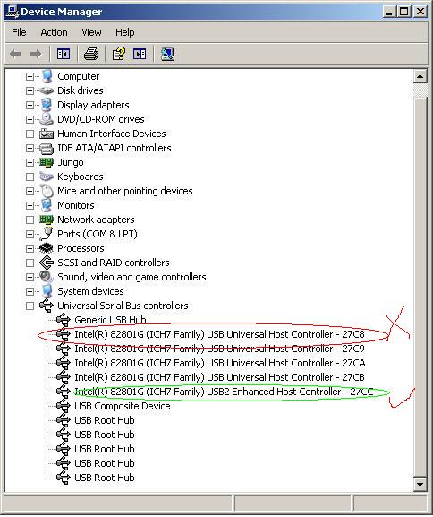
- External USB hub is allowed with restrictions below:
  - Must use independent power supply
  - Must pass the compliance test of USB org, Belkin USB hub is recommended.
  - No more than 4 devices are allowed to be connected to USB hub.

Operation Flow
Please refer to “Manufacturing Tool V2 Quick Start Guide.”

Operation Notes

- The file "mksdcard.sh" is used to create partitions on the storage medium for Linux. The size of this partition is defined by "BOOT_ROM_SIZE". In this file,it should be modified manually if necessary.

- The file "mksdcard-android.sh" is used to create partitions on the storage medium for Android. Eight partitions will be created. The sizes of these partitions are defined by "BOOT_ROM_SIZE", "SYSTEM_ROM_SIZE", and “DATA_SIZE", and so on. They should be modified manually if necessary.

- For the Android related operation, before you start it, please get the latest Android images and put them under "profiles/CHIP_PROFILE/OS Firmware/files/android". For Freescale internal users, you can get these from ftp://10.192.224.88/android_nightly/.

